 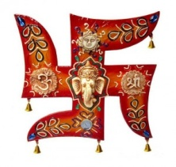 **YOUR TRAVEL ADVISER!!!!!!**

……………………………………………………………………………………………………………………………………………………………………………………………………

**BHUTAN: THE LAND OF THUNDER DRAGON**

**BHUTAN TOUR PACKAGE: 17 NIGHTS/ 18 DAYS**

Bhutan:-

A country resting peacefully in the lap of eastern Himalayas is one of those very few places that can probably take you back in time. The unadulterated nature, around 73% of the land drenched in wild greenery, the flag with dragon engraved on it, the rice that is born red, the place which is believed to be haunted by multiple demons and protected by multiple gods, the innocence of the locals that still believe that snowman exists and dragons spit fire, the land that has preserved the rarest of the nomadic tribes and fauna on the list of ‘red-alert’ is what Bhutan is made up of. Not very well known amongst the tourist crowd, Bhutan indeed offers some mystical, magical places to visit for the intrepid traveler.

**DAY 01: ARRIVAL AT IXB/NJP – TRANSFER TO PHUENTSHOLING**

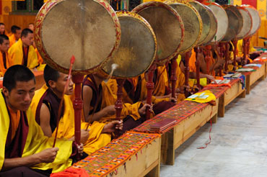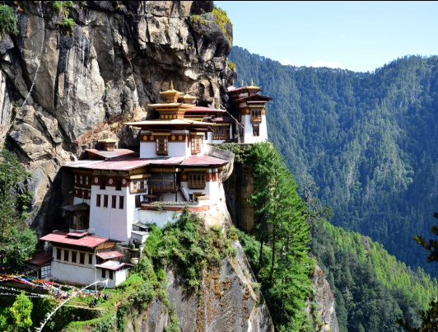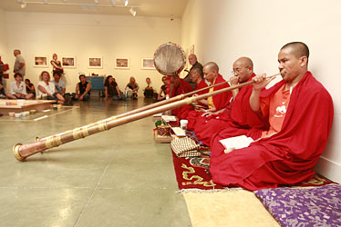

On arrival at NJP/IXB, you will be greeted by our official and transferred to Phuentsholing (298 Mts/977 Fts), a small

Town at the Indo-Bhutan border. Have your lunch in an Indian Hotel. Post lunch Immigration formalities will be done and you

Will be transfer to hotel. Evening at your own leisure. Overnight at Phuentsholing.

**DAY 02:** **TRANSFER TO THIMPHU**

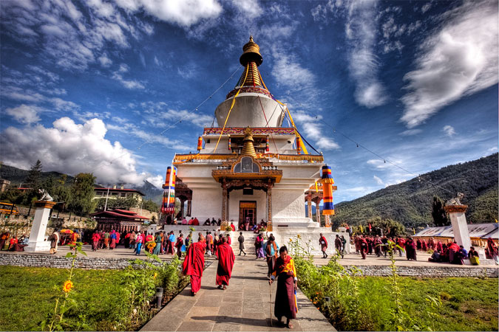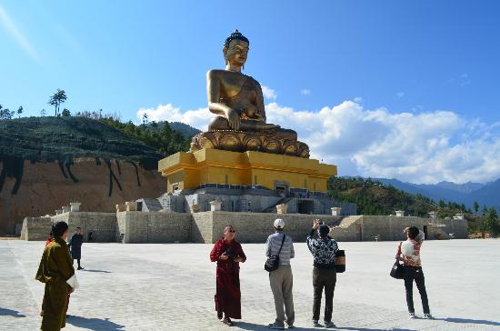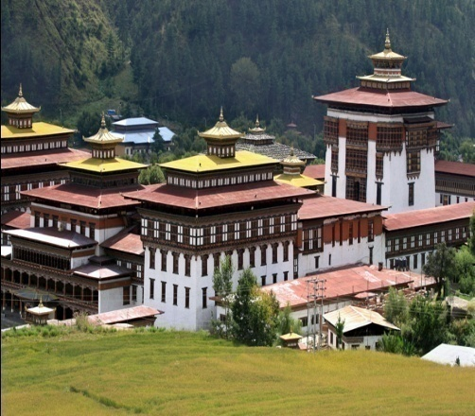

After Breakfast, check out from Hotel & Transfer to Thimphu. (178KMS/09Hrs) which lies at an elevation of 2300m. Thimphu lies in a beautiful valley, sprawling up a hillside on the west bank of the Thimphu CHHU River and has a total area of about 1809 sq. kms. Evening at your own leisure. Visitors can enjoy relaxing walk in the valley at evening. Be sure to sink your teeth into momo kopi, steam dumplings filled with finely chopped cabbage, onions, cheese and butter. Overnight at Hotel in Thimphu.

**DAY 03**: **THIMPHU CITY TOUR**

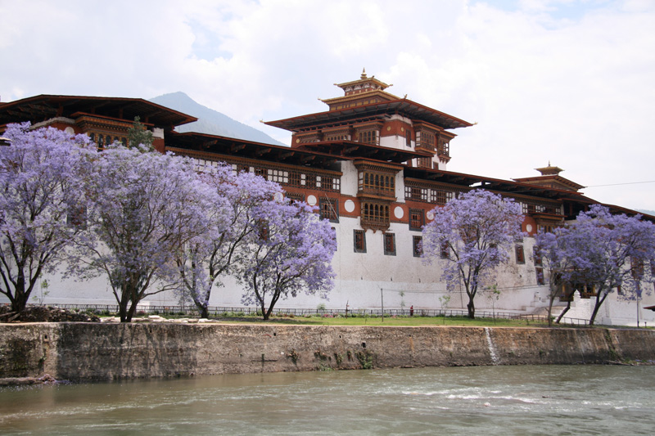 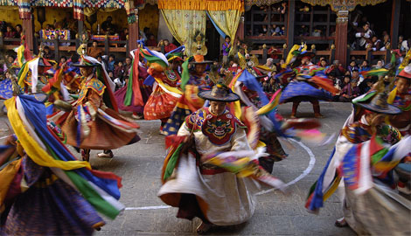

After Breakfast: Go for Major Sightseeing Covering1) Buddha Point,  2)BBS Tower,  3)Tashicchhoe Dzong, 4)The Memorial Chorten, 5)National Library, 6)The Institute of Traditional Medicine, 7)Centenary Farmer Market, 8)Changlimithang Stadium, 9)School of Arts & Crafts, 10)Handicraft Institute, 11)Zangthopelri Lhakhang, 12)Motithang Takin Reserve (Takin Zoo), 13)Semtokha Dzong. In Evening: Stroll Through The Market of Thimphu & Overnight Stay.

**DAY 04:** **EARLY MORNING TRANSFER TO WANGDUE/PUNAKHA VIA DOCHU LA** **PASS**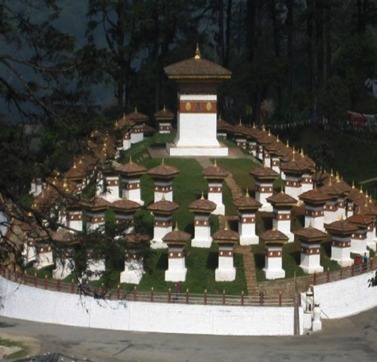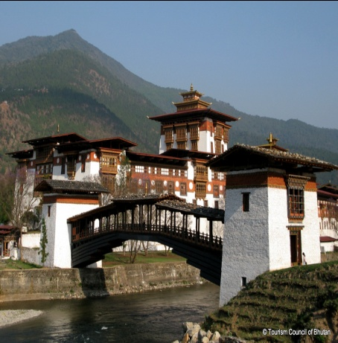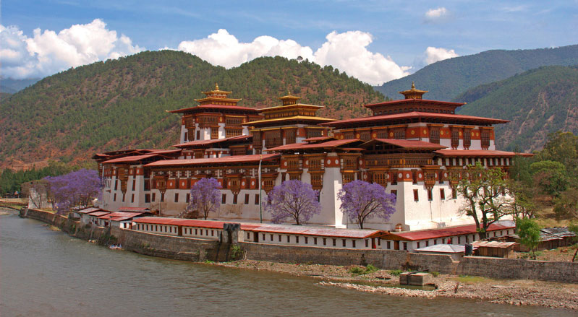

After early Breakfast, check out from Hotel & Transfer Wangduephodrang, (70 Kms/2hrs), with a stop en route for tea at Dochu LA pass (3,100 meters), where on a clear day you can get spectacular views of the Himalayans. In Wangdue, stop at Mehsina village & visit Chime lhakhang – the Temple of fertility built in 15th century by Lama Drukpa Kinley. (This monk is popularly known as the Divine Madman for his philosophy, “Salvation through Sex”), Chendebji chorten, Wangduephodrang Dzong, Phobjikhs valley on the same slope overlooking the valley is the Gangtey Gompa. Have your lunch in your way at restaurant and in afternoon drive to Punakha, the former capital of Bhutan, and visit Punakha Dzong, which is noteworthy both for being one of the most beautiful dzongs in Bhutan and also for having been built by the first Shabdrung in 1937. Overnight in Punakha.

**DAY 05 :-TRANSFER TO TRONGSA**

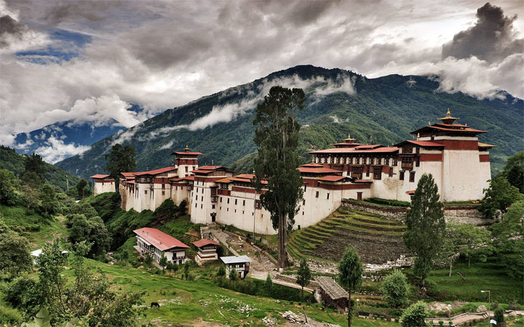 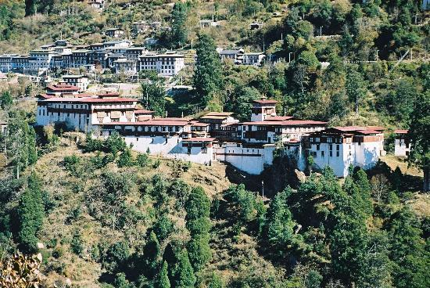

Drive down the valley to the town of Wangdiphodrang. Our road gradually winds its way up towards the Pele La Pass at 11,152ft, where we make stop for views of the snow clad peaks, including that of Bhutan’s sacred peak Mt. Chomolhari. We again make a stop for tea / coffee at Chedebji Chorten (Stupa) patterned after Swayambhunath in Kathmandu. On arrival in Trongsa, check in the hotel and after lunch we visit the inner courtyard of historical Trongsa Dzong. Trongsa is a very popular place with largest Dzong in Bhutan and certainly one of the most impressive ones. It was from here that the present royal family emerged as the most powerful force at the beginning of this century. From the fortress we walk up to the watch tower for 20 minutes passing the town of Trongsa. Overnight at hotel in Trongsa.

**DAY 06:** **TRANSFER TO BUMTHANG**

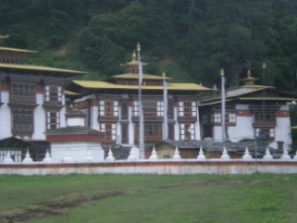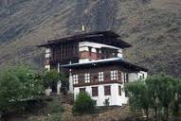

After Breakfast: Transfer to Bumthang, Switzerland of Bhutan, (which is Approx 212 Km/ 8 Hours) .Bumthang consists of the four mountain valleys of Ura, Chumey, Tang and Choekhor ("Bumthang"), Bumthang directly translates as "beautiful field" & Overnight Stay at Bumthang.

**DAY 07**: **BUMTHANG CITY TOUR**

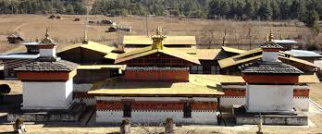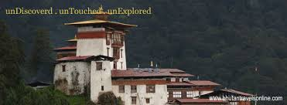

After Breakfast: Visit: 1) Mebar-Tsho (Burning Lake), 2) Kurje Monastery, 3) Jakar Dzong, 4) Jambay Lakhang, 5) Tamshing, 6) Koenchog SumLakhang, 7) Jakar Lhakhang, 8) Wangdue Choling & Overnight Stay.

**DAY 08:- TRANSFER TO MONGAR**

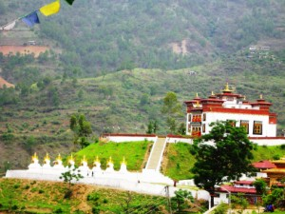 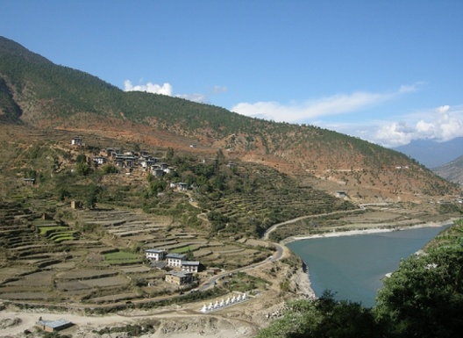 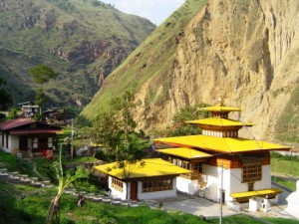

The journey continues eastwards winding through more rugged terrain. The drive withspectacular views will take about 7 hours. Pass through Ura village in Bumthang before climbing sharply to the highest motorable pass in the Kingdom, the Thrumshingla pass (4,000 m). Gradually drop down to Sengor, watching cascading water falls on the way.  
  
The descent stops at 700m, on a bridge over the Kurichu. Ascent again through pine forest, maize fields and eastern hamlets to Mongar town. Visit Mongar Dzong, built albeit quite recently, the dzong still maintains the architectural traditions of old dzongs. Overnight at the lodge in Mongar.

**DAY 09:- TRANSFER TO TRASHIGANG**

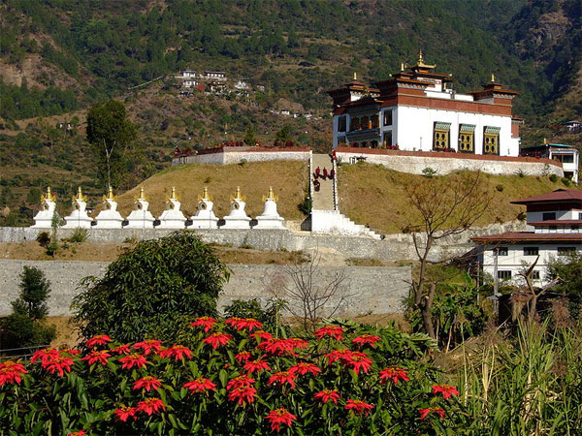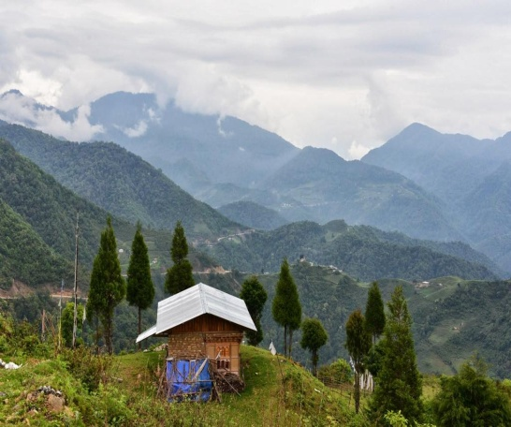 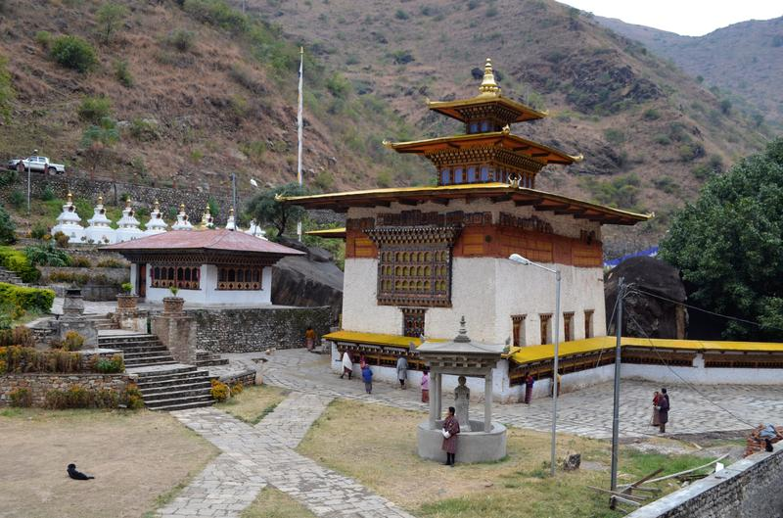

This trip of about 96 km takes 3 hours passing through Kori la pass (2,450m), the place marked by a pretty chhorten and a stone wall. The first part of the journey is through leafy forest filled with ferns. Later road descends rapidly through corn fields and banana groves arriving the famous ziazags of Yadi, which is a recent settlement. After that follows the Gamri river until the bifurcation to Dametsi, this temple perched on top of steep hill was founded by Choeden Zangmp and is the most important monastery of eastern Bhutan. This is the place from where famous Naga Chham, mask dance with drums originated. About 30 km onwards lies Trashigang at 1000m. Trashigang is the centre of the biggest and most populated district in the country. Visit Trashigang Dzong, standing at the extreme end of the spur, overhanging the Gamri river. It serves as the administrative seat for the district and part of the Dzong is occupied by the Drukpa monastic community. Overnight at the lodge in Trashigang.

**DAY 10:-TRASHIGANG (EXCURSION TO TRASHIYANGTSE)**

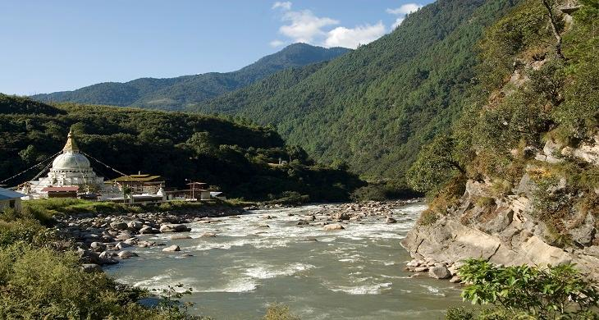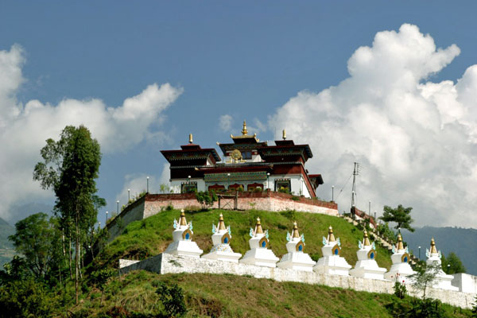

24 km from Trashigang, visit the temple of Gom Kora, set on a small alluvial plateau, overlooking the river. Gom Kora is a famous place where Guru Rinpoche subdued a demon. Further ahead reach to Doksum village where you can see women busy in weaving traditional Bhutanese fabric and a chain bridge dating of the 15th century.  
Visit to Trashiyangtse Dzong, situated at the altitude of 1,850m. In former times Trashiyangtse was important centre because it lies on one of the carven routes leading from western and centre Bhutan. The Dzong is new and near by are the Art School and the famous Chhorten Kora.  
Evening return to Trashigang. Overnight at the lodge in Trashigang.

**DAY 11:-TRANSFER TO BUMTHANG**

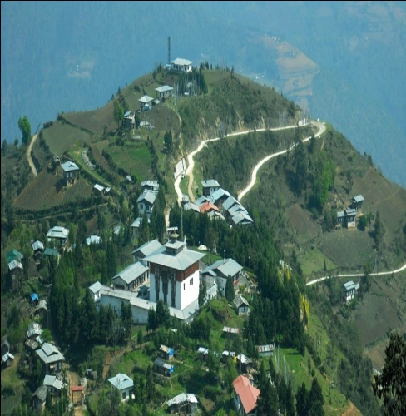 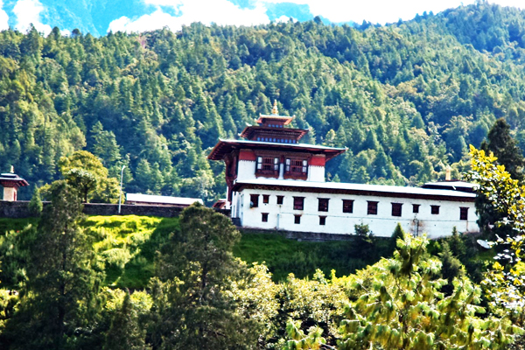 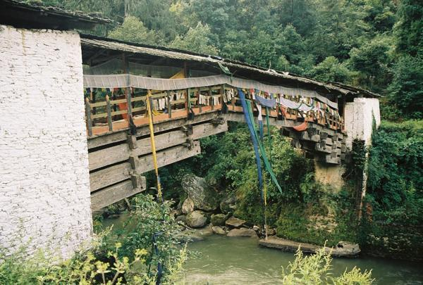

After breakfast drive back to Bumthang with lunch enroute. Overnight at the lodge in Bumthang.

**DAY 12 :-BUMTHANG TO GANGTEY/PHOBJIKHA(190KM.7 HOURS DRIVE)**

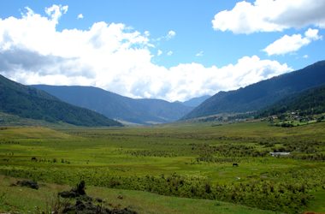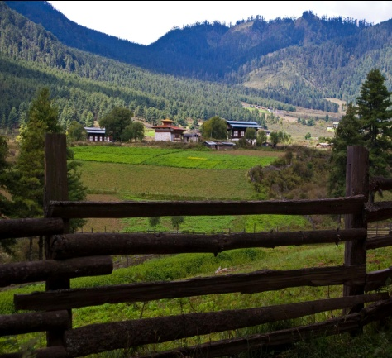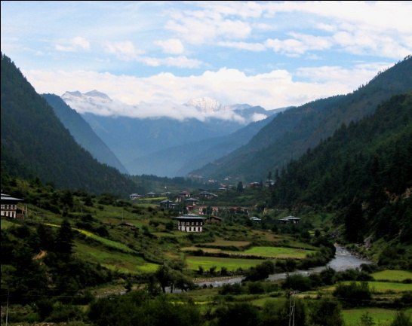

After breakfast drive to Gangtey / Phobjikha. In the mountains east of Wangduephodrang liesthe beautiful Phobjikha valley, on the slopes of which is ituated the great monastery of Gangtey, established in the 17th century. The village of Phobjikha lies a few km, down from the monastery, on the valley floor. This quite, remote valley is the winter home of black necked cranes, which migrate from the arid plains of Tibet in the north, to pass the winter months in a milder climate. Explore Gangtey village and Phobjikha valley.  
  
Overnight at the lodge in Gangtey / Phobjikha.

**DAY 13**: **TRANSFER TO W / DUE OR PUNAKHA**

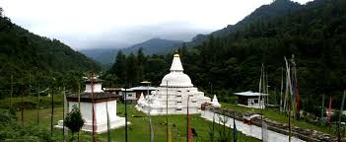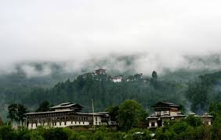

AFTER BREAKFAST TRANSFER TO WANGDUE AND NIGHT STAY AT WANGDUE.

**DAY 14: TRANSFER TO PARO**

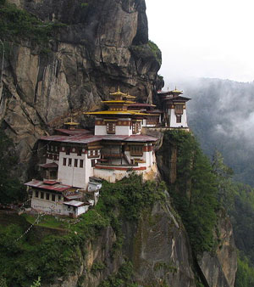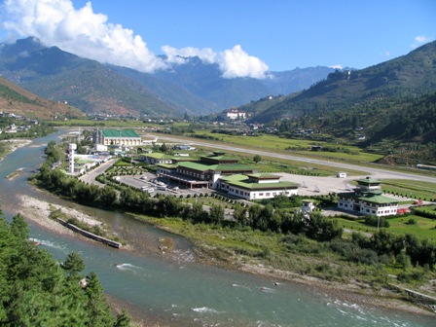 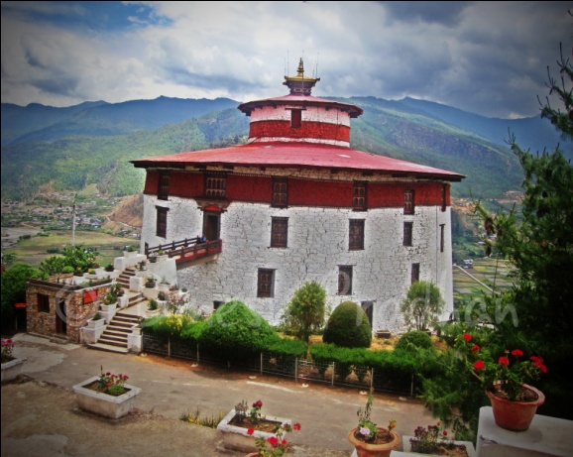

After Breakfast, check out from Hotel & Transfer to Paro. Paro is Destination of Scenic beauty, the only International airport of Bhutan in Paro. It has a population of 39,800 (which is approx 1 and half hours/65 KM from Thimphu). – visit the historic ruins of the Drukgyal Dzong, built in 1647. Paro’s Main street features shops on both sides, all crammed with brasswares, silk and cotton scarves, incense sticks, silver filigree jewellery, gho (Bhutanese National Dress for Men) which can be matched with elaborately embroidered boots, kira (wrap-around sarong worn for Bhutanese Women) and prayer flags that one could string across any open space to seek blessings for loved ones and friends. Evening at your own leisure. Overnight in Paro.

**DAY 15: PARO CITY TOUR**

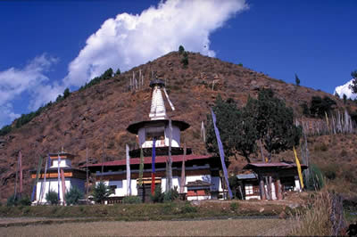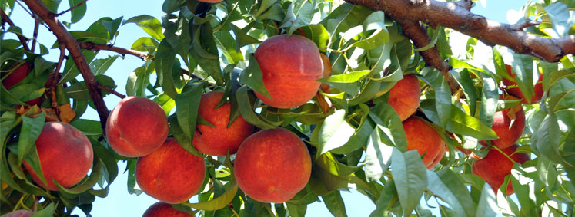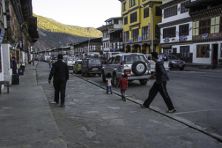

After Breakfast: Visit -1) View of Taktshang Monastery, 2) Kichulanka Monastery, 3) Ta Dzong, 4) Paro Rinpung Dzong (Museum), 5) Nya-mey Zam, 6) Dungtse Lhankhang, 7) Kila Gompa, 8) Druk Choeding. In Evening: Stroll Through the Market of Paro & Overnight Stay in Paro.

**DAY 16: CHELE LA PASS & HAAVALLEY**

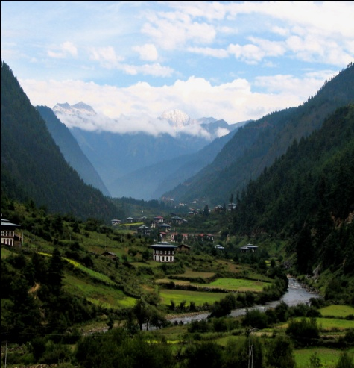 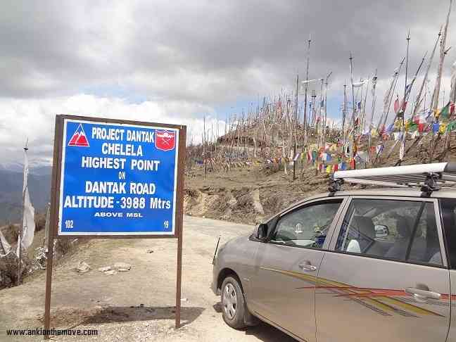 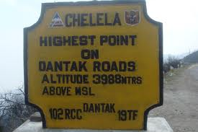

After Breakfast: Excursion To PARO Extra Point: Chele La (Pass) & Haa Valley Only (Border of the Bhutan and China):  At an elevation 3,988 meters is considered to be one of the highest motorable passes in Bhutan. About an hour's drive along a thickly-forested road, is this Pass-a botanical paradise. The pass provides stunning views of the sacred mountain Jhomolhari and Jichu Drake. It is also marked by hundreds of prayer flags fluttering in the wind. Here, visitors can see cascades of wild roses; purple and yellow primulas; and swathes of deep blue iris covering the forest floor. The top of the pass bloom with rhododendrons in a variety of colors-pale pink, deep pink, burnt orange, mauve, white and scarlet. In Evening: Stroll Through the Market of Paro& Overnight Stay at Paro.

**DAY 17: TRANSFER TO PHUENTSHOLING**

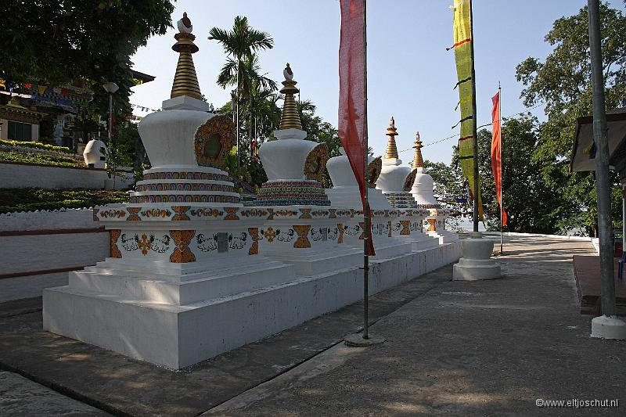 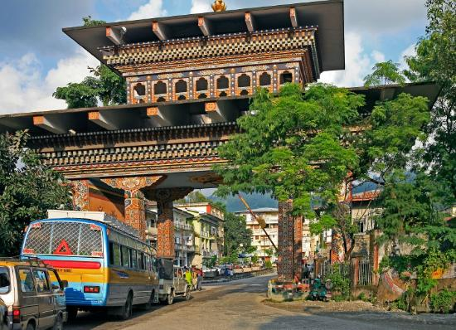

After breakfast check out from Hotel proceeds to Phuentsholing.

**DAY 18: PHUENTSHOLING TO BAGDOGRA DROP**

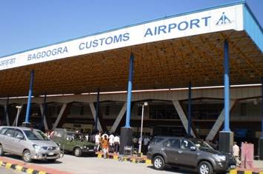 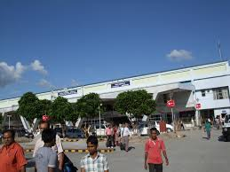

After breakfast check out from Hotel and proceeds to Bagdogra airport. And tour end with sweet memories.

**SIGHTSEEING PLACES IN BHUTAN**

**IN THIMPHU**

Thimphu is the capital of Bhutan and the largest town in Bhutan. It lies at an altitude of 2400 metres. All government headquarters and centre for trade are located here. The following are the places of tourist attraction in Thimphu.

* **Trashichho Dzong**: Meaning “fortress of the glorious religion “was initially erected in 1641 and rebuilt by King Jigme Dorji Wangchuck in the 1960s. It is one of the largest Dzong in Bhutan. The Dzong houses the throne room and office of his majesty and is the seat of government and religious affairs in the kingdom. The northern portion of the Dzong has the summer residence of the central monastic body and his holiness the Je Khenpo (chief abot). It is open to visitors only during the Thimphu Tsechu (held in autumn) and during winter when the monk body moves to punakha.

* **National Memorial Chorten**: this monument was built in 1974 in the memory of the late King Jigme Dorji Wangchuck. It was originally the idea of Bhutan’s third King, H.M. Jigme Dorji Wangchuck to erect a monument for world peace and prosperity, but could not be done due to his untimely death. So after his death, it was built to in his memory and to serve as a monument for world peace.
* **Simtokha Dzong**: built in 1627, it is the oldest Dzong in the country. The most noteworthy artistic feature of this Dzong is the series of over 300 finely worked slate carvins behind the prayer wheels in the courtyard which are centuries old the paintings inside this Dzong are believed to be some of the oldest and the most beautiful in the country.
* **National library**: The National Library was established in the late 1960s and it houses an extensive collection of Buddhist literature mostly in block-printed format and some works are several hundred years old. There is also a small collection of books in English on the ground floor mainly on Buddhism, Bhutan, the Himalayan region and neighboring countries.
* **Institute for Zorig chusum**: commonly known as the painting School is an institute established primarily to preserve and promote Bhutan’s unique artistic tradition which played a vital role in moulding its distinct heritage. The Institute offers a six year course on the 13 tradition arts and crafts of Bhutan and on a visit one can see students learning the various skills taught at the school.
* **National Institute of Traditional medicine**: The Institute was established in 1967 as a center for indigenous medicines and practice. In olden times. People primarily relied on the indigenous medicines to cure their illness. The Institute also serves as a training school for traditional medicine practitioners. The complex is closed to visitors due to considerations of hygiene, but one can still walk around and view it from outside.
* **Buddha Point (Kuensel Phodrang)**: Located at a short drive from Thimphu city centre, visitors can get a good overview of the Thimphu valley from the Buddha point (Kuensel Phodrang). You can pay your obeisance and offer prayers to the Buddha, the largest statue in the country and then walk around and take a glimpse of the valley.
* **Botanical Gardens, Serbithang**: Located on lush hillside about 10km from the city, the gardens offer a peaceful and relaxing environment to spend a few hours. Botanists will find the wide selection of indigenous trees and plants of interest.
* **Coronation Park**: Located on the banks of the river (near the city stadium), these 5.6 acres of parkland offer a pleasant and relaxing environment to stroll or to sit and watch the river flow by.
* **The Folk Heritage Museum (Phelchey Toenkhyim):** It is dedicated to connect people to the Bhutanese rural past through exhibits, demonstrations, educational programmes and documentation of rural life. The principal exhibit in the museum is a restored three storey traditional rammed mud and timber house, which dates back to the mid 19th century. The design and form of house is that of an average household in the Wang area during that era. The age of structure demonstrates the durability and performance of the building materials. From ground to top floor, household objects, typical domestic tools and equipments that would have been used by a family during that period are put on display. The museum is also developing some of the native trees and plants that were used for various domestic purposes in the rural households.
* **Weekend Market**: Every Saturday and Sunday most of Thimphu's scant population and many valley dwellers congregate on the banks of the river where weekend market is held. It is an interesting place to visit and provides opportunity to mingle with the local people.

**IN PARO**

Paro (alt. 2200m/7218ft) - The beautiful valley of Paro encapsulates within itself a rich culture, scenic beauty and hundreds of myths and legends. It is home to many of Bhutan's oldest temples and monasteries, National Museum and country's only airport. Mount. Chomolhari (7,314m) reigns in white glory at the northern end of the valley and its glacial water plunge through deep gorges to form Pa Chhu (Paro River). Paro is also one of the most fertile valleys in the Kingdom producing a bulk of the locally famous red rice from its terraced fields.

Places of interest in and around Paro:-

* **Taktshang Lhakhang (Tiger's Nest):** It is one of the most famous of Bhutan's monasteries, perched on the side of a cliff 900m above the Paro valley floor. It is said that Guru Rinpoche arrived here on the back of a tigress and meditated at this monastery and hence it is called "Tiger's Nest". This site has been recognized as a most sacred place and visited by Shabdrung Ngawang Namgyal in 1646 and now visited by all Bhutanese at least once in their lifetime. On 19 April, 1998, a fire severely damaged the main structure of building but now this Bhutanese jewel has been restored to its original splendour.
* **Rinpung Dzong**: Built in 1646 by Shabdrung Ngawang Namgyal, the first spiritual and temporal ruler of Bhutan, the Dzong houses the monastic body of Paro, the office of the Dzongda (district administrative head) and Thrimpon (judge) of Paro district. The approach to the Dzong is through a traditional covered bridge called Nemi Zam. A walk through the bridge, over a stone inlaid path, offers a good view of the architectural wonder of the Dzong as well as life around it. It is also the venue of Paro Tshechu, held once a year in the spring.
* **Ta Dzong**: One time watch tower built to defend Rinpung Dzong during inter-valley wars of the 17th century, since 1967 Ta Dzong is serving as the National Museum of the country. It holds fascinating collection of art, relics, religious thangkha paintings and Bhutan's exquisite postage stamps. The museum circular shape augments its varied collection displayed over several floors.
* **Drukgyel Dzong**: This Dzong, with a delightful village nestling at its foot, was built in 1646 by Shabdrung Ngawang Namgyal to commemorate his victory over the Tibetan invaders. Historically and strategically this Dzong withstood all its glory and was featured in 1914 vide National Geographic magazine. The glory of Drukgyel Dzong remained even when it was destroyed by fire in 1951. On a clear day, one can see the commanding view of Mount. Chomolhari from the village, below the Dzong.
* **Kyichu Lhakhang**: It is one of the oldest and most sacred shrines of the Kingdom dating back to 7th century (the other is Jambey Lhakahng in Bumthang). The lhakhang complex is composed of two temples. The first temple was built by Tibetan King, Songtsen Gampo in the 7th century and in 1968, H.M. Ashi Kesang, the Queen Mother of Bhutan, built the second temple in original pattern.
* **Dungtse Lhakhang**: To the west of the road is Dungtse Lhakhang, a chorten-like temple. This unusual building was built in 1433 by the iron bridge builder Thangtong Gyalpo. It has three floors representing hell, earth and heaven and the paintings inside are said to be some of the best in Bhutan.   
    
  Beyond Dungtse Lhakhang, to the east of the road, the tiny Pana Lhakhang is quite old and is believed to have been built in the seventh century.

**In punakha**

Punakha (alt. 1300m/4265ft) - Punakha served as the capital of Bhutan until and still it is the winter seat of Je Khenpo (the chief abbot). Blessed with temperate climate and owing to its natural drainage from Pho Chhu (male) and Mo Chhu (female) rivers, the Punakha valley produces abundant crops and fruits. There are splendid views of the distant Himalayas at Dochula pas (alt. 3,050m) on Thimphu – Punakha road.

Places of interest in and around Punakha

* **Punakha Dzong**: Built strategically at the junction of Pho Chhu and Mo Chhu rivers in 1637, by Shabdrung Ngawang Namgyal to serve as the religious and administrative centre of the region, Punakha Dzong has played an important role in Bhutan's history. Damaged by four catastrophic fires and an earthquake, the Dzong has been fully restored by the present King. The Dzong is open for visitors during Punakha festival and in summer months when the monk body moves to Thimphu.
* **Khamsum Yulley Namgyal Chorten**: A beautiful hike takes one to the regal Khamsum Yuelley Namgel Chorten, which was built to remove negative forces and promote peace, stability and harmony in the changing world. The Chorten dominates the upper Punakha Valley with commanding views across the Mo Chhu and up towards the mountainous peaks of Gasa and beyond.

**IN BUMTHANG**

Places of interest in and around Bumthang or Jakar   
  
**Jambay Lhakhang** : This monastery was built in the 7th century by Tibetan King, Songtsen Gampo. It is one of the 108 monasteries built by him to subdue evil spirits n the Himalayan region. Its present architectural appearance dates from the early 20th century.   
  
**Kurje Lhakhang** : Situated before Jambay Lhakhang, Kurje Lhakhang consists of three temples. The one on the right was built in 1652 on the rack face where Guru meditated in the 8th century. Second temple is built on the site of a cave containing a rock with the imprint of Guru's body and is therefore considered the most holy. The third temple was built in 1990s by Ashi Kesang, the Queen Mother. These three temples are surrounded by a 108 chorten wall.   
  
**Tamshing Lhakhang**: Located across the river from Kurje Lhakhang, this temple was founded in 1501 by Terton Pema Lingpa, the re-incarnation of Guru Padsambhava. The monastery has very ancient religious paintings like 1,000 Buddhas and 21 Taras (female form of Buddhistava). The temple was restored at the end of the 19th century.   
  
**Jakar Dzong** : Founded by great grand-father of the first Shabdrung, the Dzong was initially built as a monastery in 1549. It was upgraded after the Shabdrung had firmly established his power in 1646. The Dzong is now used as administrative centre for Bumthang valley, and houses the regional monk body.  
  
**Konchogsum Lhakhang**: It was built in the 6th century but was renovated in 1995, which accounts for its fresh look. It contained a large bell and it is said that when this bell was rung it could be heard all the way in Lhasa in Tibet. During the 17th century a Tibetan Army tried to steal this bell but was too heavy and they dropped it and cracked it. It is now displayed at the National Museum in Paro.  
  
**Chankhar Lhakhang** : Beyond Jambay Lhakhang is Changkhar Lhakhang, the site of the palace of the Indian King Sindhu Raja. Because of its simplicity it looks like an ordinary village house. The original palace was built of iron and this is why it was named Chankhar, meaning iron castle. It was rebuilt in the 14th century by a Saint called- Dorji Lingpa.

**Lhodrak Kharchhu Monastery**:  
Located above the main town, about 3 km from Chamkhar town, the monastery was founded by Namkhai Nyingpo Rinpoche in 1984 who was recognized at a very young age by H.H. the 14th Dalai Lama and H.H. 16th Karmapa as the reincarnation of a Tibetan lama whose spiritual lineage dates back to the nearest disciples of the great 9th century master. Since then the monastery has developed considerably with increase in number of monks to almost four hundred. The monastey has become part of an extensive effort to preserve and revitalize Tibetan culture. The monks regular curriculum include reading, memorizing the daily prayers, learning dharma dances, drawing mandalas, learning the melodies of sacred rituals, learning the use of ceremonial instruments and the art of making sacrificial objects, grammer, poerty, karika along with the basics of contemplation and instruction on the different stages of tantra.   
  
Excursions around Bumthang or Jakar valley

**Tangbi Goemba**: A walk of half an hour north of Kurje Lhahang leads to this monastery, founded in 1470 by Shamar Rinpoche of the Kagyupa religious school. The temple has two sanctuaries and a temple of terrifying deities. The sanctuary on the ground floor contains statues of past, present and future Buddha and three clay statues probably dating end of the 15th century. On the upper floor, the vestibule contains two remarkable paintings of Guru Rinpoche's heaven and the Buddha Amitabh's heaven.

**Ngang Lhakhang**: A few hours walk from the Tangbi Goemba is the small region of Ngang Yul (Swan Land) and this temple here is 100 m above the valley floor. The site was visited by Guru Rinpoche and present temple was built in the 15th century by Lama Namkha Samdup, a contemporary of Pema Lingpa. A three days festival is held here each winter with masked dances in honor of the founder of the temple.

**Ura Valley**: Jakar to Ura is 48 km, about one and a half hour drive. To reach here, the road climbs toJakar valley Bhutan amazingly open countryside, only occasionally running into forest. Large sheep pastures line the road up to 20 km behind the southern tip of the Tang valley. The route crosses Ura la pass (3,600m) with a magnificent view of Mount. Gangkhar Puensum. Villages in Ura have clustered houses, which is quite unusual in Bhutan. Above Ura village (3,100m) is a new temple dedicated to Guru Rinpoche. Inaugurated in 1986, it contains a huge statue of the master and remarkable paintings of the cycle of his teachings. Since last 25 years Ura has been transformed from a marginal community to prosperous valley.

**Tang Valley**: Terton (treasure discoverer) Pema Lingpa, the famous saint, was born in the Tang valley of Bumthang. The people of this valley raise sheep and at higher elevation, yaks as the soil in this region is not so rich for agricultural activities. From Bumthang central, it is a short drive past the Dechenpelrithang sheep farm to an unpaved road that leads to the north. Just under a kilometer ahead, there is a rough track on the left and another kilometer ahead, there is junction where vehicle can be parked. From parking, it is a short walk down to the river. The path is lined with prayer flags and ends up above a gorge where the river forms a pool before it rushes on. Images of Pema Lingpa and his two sons are carved on a rock here.

Membartsho (The Burning Lake) in Tang valley is a wide spot on the Tang Chhu (chhu - water / river) and is considered to be one of the greatest pilgrimage sites of Bhutan. Pema Linga found several of Guru Rinpoche's hidden treasures here. The importance of this site is indicated by the extensive array of prayer flags and the small clay offerings called 'Tse Tsa' in rock niches.

**IN MONGAR**

**Mongar Dzong**  
It is site of one of Bhutan's newest Dzong built in 1930s. Yet the Dzong is built in the same method and traditions of all the other Dzongs; no drawings and nails have been used. A visit gives visitors an impression of how traditional Bhutanese architecture has continued to thrive through the centuries.

**Yakang Lhakhang**   
Located at about 20 minutes walk from Mongar town, this privately owned monastery was founded by Lama Sangdag, the sixth son of Terton Pema Lingpa. It is of great cultural significance and a repository of a wide range of spiritual treasures and other sacred objects known to have been revealed by Terton Pema Lingpa.

**Drametse Lhakhang**Dramtse Lhakhang means, ‘the peak without enemy’, is one of the largest and most important monastery in eastern Bhutan, situated about 18 km away from Trashigang to Monger highway. The lhakhang was founded by a highly accomplished Ani (nun) named Choten Zangmo in the 16th century, the granddaughter of the famous religious master Terton Pema Lingpa (the Treasure Discoverer).   
The lhakhang is deeply associated with Terton Pema Lingpa and the Peling tradition of Buddhism. It houses a full range of spiritual treasures and other sacred objects and is the source of spiritual inspiration to the people of Drametse and neighbouring communities.

The local people from Mongar and Trashigang gather at Drametse Lhakhang to witness the annual religious festival, celebrated every year on the 10th day of Bhutanese calendar and  locally known as Kaggsol Chenmo, Trel Da Tshechu and Daw Drugpai Choep. The Drametse Ngacham (Dance of the drums of Drametse) was established by Lam Kuenga Gyeltshen, Ani Chhoeten Zangmo’s brother.

**IN TRASHIGANG**

**Trashigang Dzong**Built in 1659, the Dzong serves as the administrative seat for the district as well as the home of the monk body. The Dzong commands a remarkable view over the surrounding countryside.  
  
**Gom Kora** - 24 km from Trashigang, the temple of Gom Kora is set on a small alluvial plateau overlooking the river. Surrounded by rice fields and clumps of banana tress, it looks like an oasis in an arid landscape. It is one of the famous places where Guru Rinpoche meditated in order to subdue a demon who dwelt in a huge black rock.

**IN PHOBJIKHA/GANGTEY**

**Gangtey Goempa**  
Perched on a small hill that rises from the valley floor, the Gangtey Monastery is the only Nyingmapa monastery on the western side of the Black Mountain’sGangtey valley, Bhutan and also the biggest Nyingmapa monastery in Bhutan. The Monastery is surrounded by a large village inhabited mainly by the families of the 140 Gomchens who take care of the Monastery.

Gangtey was founded by Pema Trinley, the grand son of Pema Lingpa, the famous Nyingmapa saint of Bhutan. In 1613, Pema Trinley establish the monastery and became the first Gangtey Tulku. The religious traditions of Pema Lingpa still taught there. The second Tulku, Tenzin Legpa Dondrup (1645 to 1726), enhanced the size of Gangtey while keeping up good relations with Drukpas, and rebuilt the monastery in the form of a Dzong.

**Black Necked Crane Information Centre**

Situated on the edge of the forest and wetland along the main road of Phobjikha valley, the black-necked crane information Centre has an observation room equipped with high power telescope and spotting scopes for catching the best view of the cranes. The centre also offers display information that outline the natural and cultural history of the area. There is a small gift shop, which sells handicrafts produced by the local people.

**Documents required to enter in Bhutan are:**

At Bhutan Immigration

* Voter Identity Card
* Passport
* Adhar Card
* Passport Size color Photograph (2 Nos)

In case of not holding the above document, you need to approach to the office of consulate of India, India Embassy for getting permission for entry into Bhutan. The following documents are requires at the office of consulate general of India,

India Embassy for identification of Indian Citizenship.

* Driving License
* Pan Card
* Ration Card
* School/College Identity Card with Photo for those who are less than 18 years.
* Marriage certificate

Note: Indian Embassy is closed on Saturday & Sunday. Permit on Saturday & Sunday is issued by main gate office, department of immigration, Phuentsholing, Bhutan.

**PAYMENTS TERM**

* 25 % at the time of booking and balance 10 days prior travel date.
* No booking are guaranteed without advance payment and rates are subject to availability.

**CANCELLATION POLICY**

* Less than 7 days prior to Date of Travel: 100% of the package cost as cancellation charge.
* 7-15 days prior to Date of Travel: 75% of the package cost as cancellation charge.
* 16-30 days prior to Date of Travel: 50 % of package cost as cancellation charge.
* More than 30 days: Full refund of package cost excluding processing fees.

**TERMS AND CONDITIONS**

* R.S travels reserves the right to re- arrange itinerary to suit hotel availability without changing the hotel number of days in each destination and without compromising any services.
* The vehicle used is Ac or Non Ac and is available for point to point services only and is not at disposal. Clients are requested to follow the itinerary.

**DO’S IN BHUTAN**

* Although Bhutan welcomes foreigners these days especially for those on their last minute all inclusive holidays, the country is extremely conscious regarding its culture.
* The greeting in the Bhutanese language Dzongkha for hello is Kuzu Zangpola, and says Tashi Delek for good bye or good luck.
* All the citizens, except India and Bangladesh, need VISA to enter into Bhutan.
* VISA should be applied minimum 30 days before you plan to visit Bhutan
* One need is route permits to travel in Bhutan and this is provided by the Immigration Office at Thimphu.
* Either carries Nu (Bhutan’s Currency) or INR (Indian Rupees). Both is accepted in Bhutan, though 500 and 1000 Indian rupee notes might not be as easily accepted.
* Use right hand while giving or receiving something. Pass the holy sites keeping them on your right side.
* US dollars are pretty widely accepted in Bhutan, but you are still advice to exchange some of your currency to Bhutan’s currency i.e. ngultrum (Nu) or Indian rupee for buying small items and for the really remote places. There are not many ATM machines nearby except major cities like Thimphu, where also international ATM/credit cards might or might not work.
* Do bring MasterCard- not Visa or other credit cards. Banks, ATM’s will not give cash on a Visa credit card in Thimphu or Paro and other areas as well and only a few merchants will take credit cards.

**DON’T’SIN BHUTAN**

* TOBACCO IS ABSOLUTELY PROHIBITED IN Bhutan. The tourists might use it, but extra care should be taken. Selling or giving tobacco to the locals is also a crime.
* Make sure you take off your footwear before you enter into any religious place.
* You are advised to dress discretely and modestly in Bhutan. If you’re visiting any Bhutanese temple (Tsechu), they’d admire you if you wear their national dress gho & kira. Also make some donation to Tsechu.
* Foreign nationals are not permitted to carry Indian rupees across the border to and from India.
* Buying and selling of antiques is strictly forbidden in Bhutan. Don’t jump to give toys or treats to children in exchange for photo offers. Locals are careful not to breed a generation of children who beg tourist, as happens-but adults likely will not object out loud out of politeness.

The following points are to be noted for Child rate:-

* Children above 10+ years will be charged 100% as per adult rate.
* Children of 5+ to 10 sharing parent’s room will be charged as per CWB or CNB
* Children below 5 years complimentary.

(Hotels are very strict with the child policy. Please carry the age proof so that it can be produced when asked)